EC2 Challenges
Launch one EC2 instance using Amazon Linux 2.

Install Docker.
Yum update
Yum install docker
Systemctl start docker
Systemctl status docker
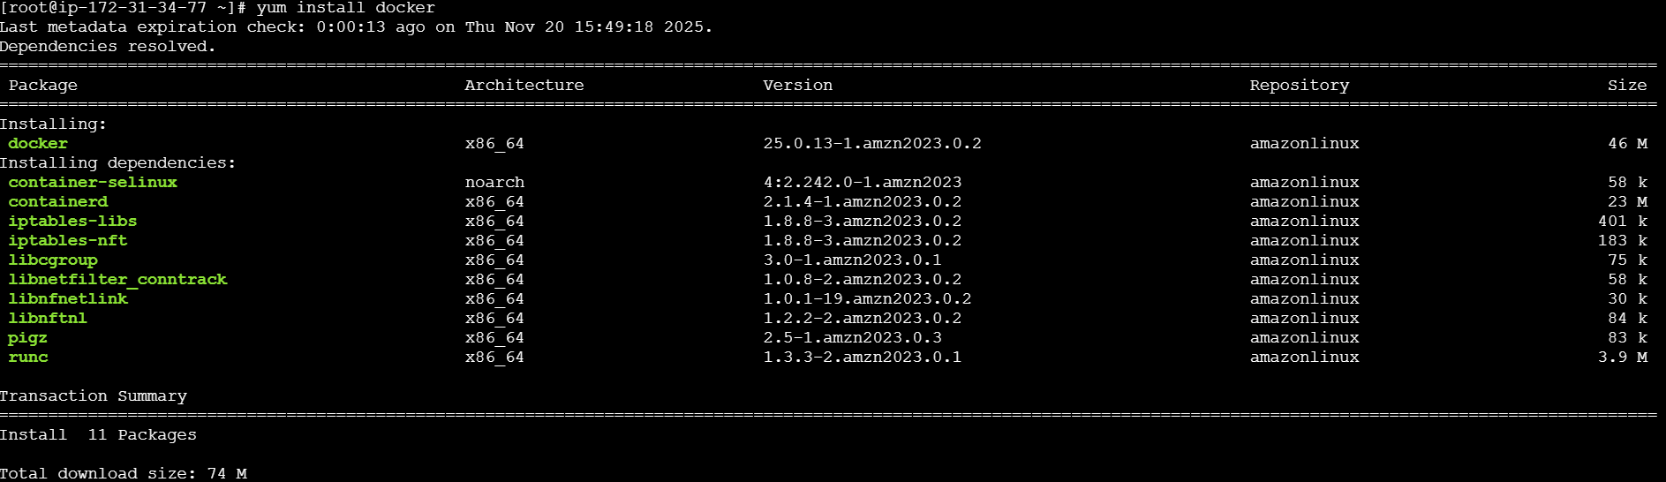
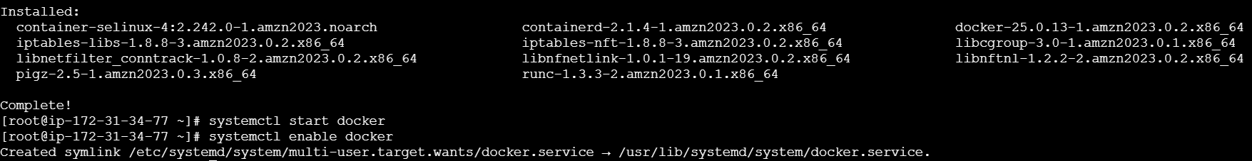

Install Jenkins.
First we need to install java version
Then sudo dnf install -y Jenkins
systemctl enable Jenkins
sytemctl status jenkins
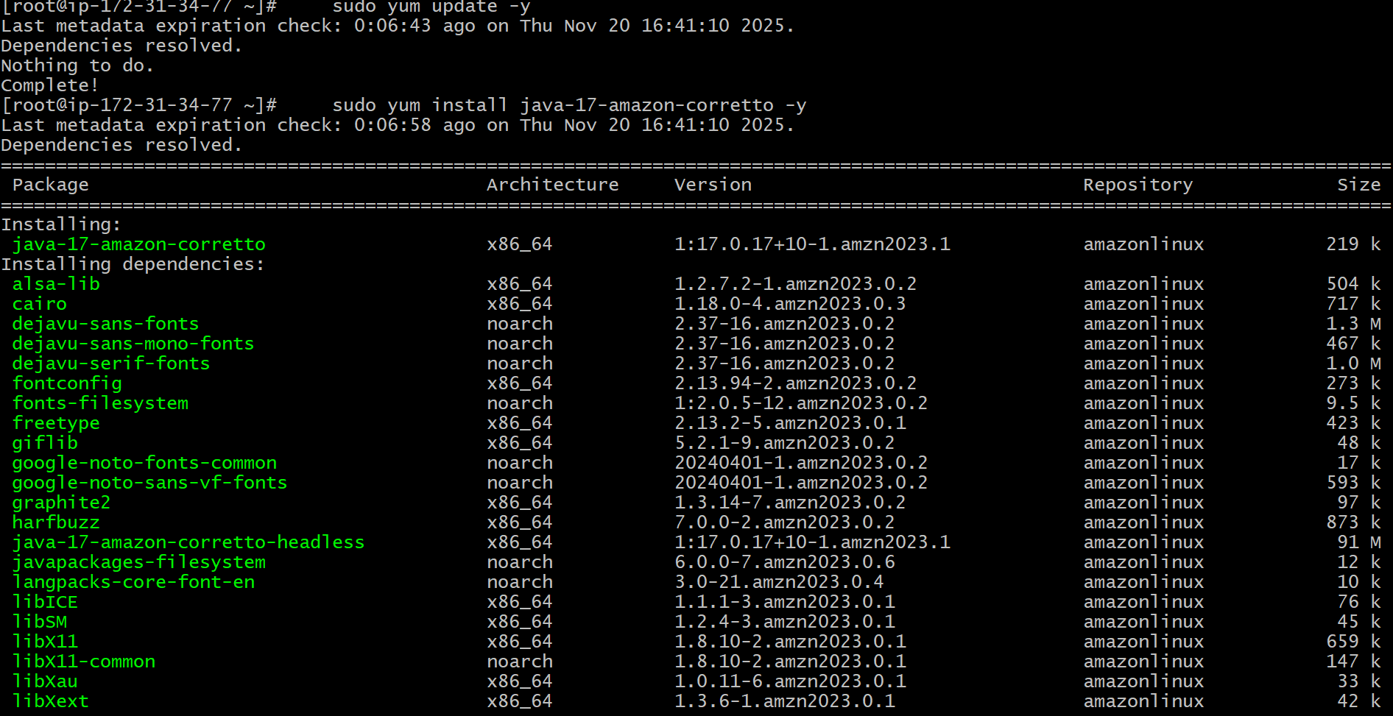

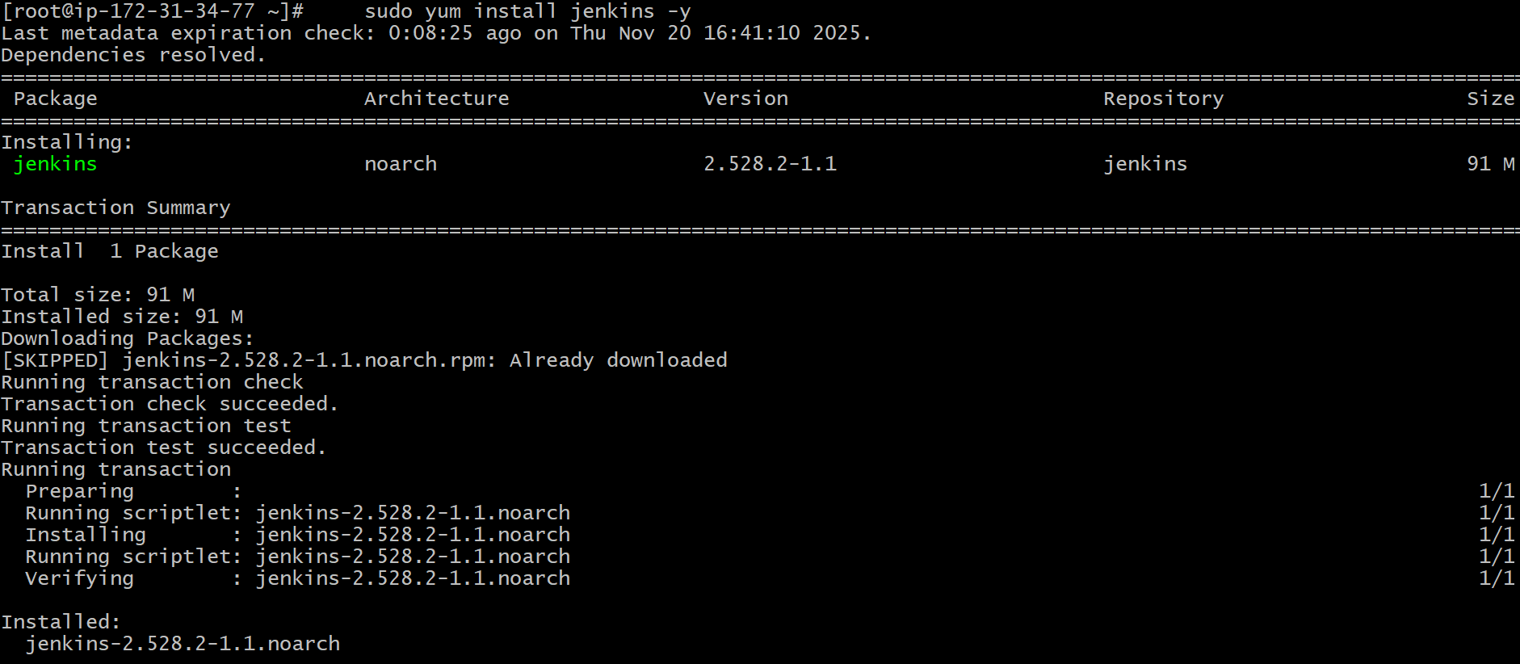
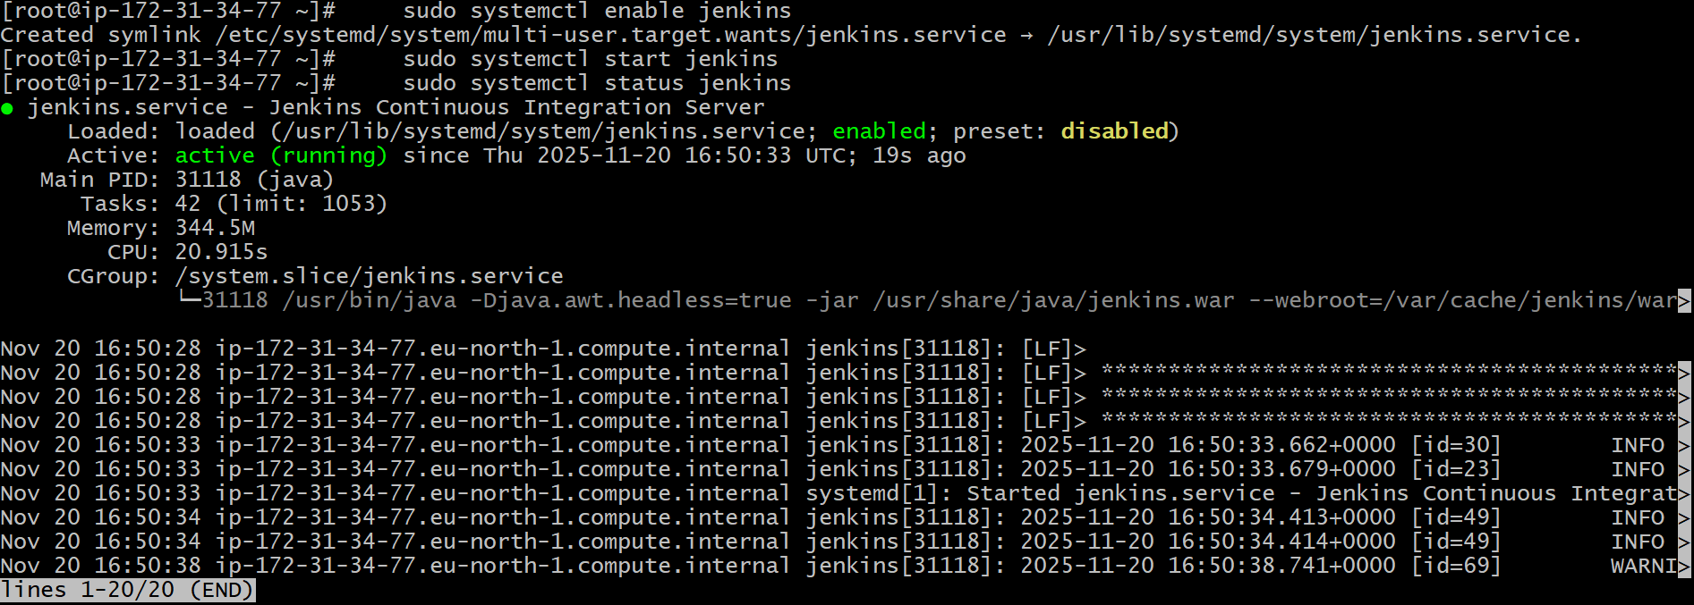
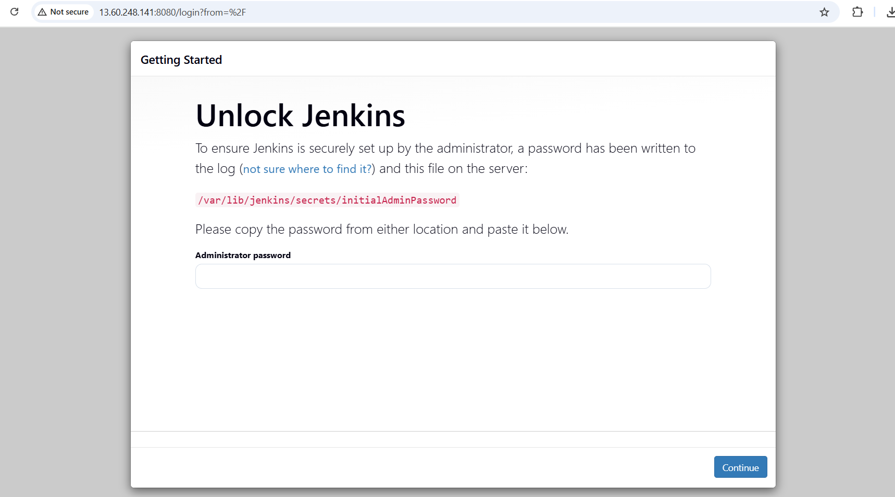

Install nginx.
Yum update -y
Yum install nginx -y
Systemctl start nginx
Systemctl status nginx
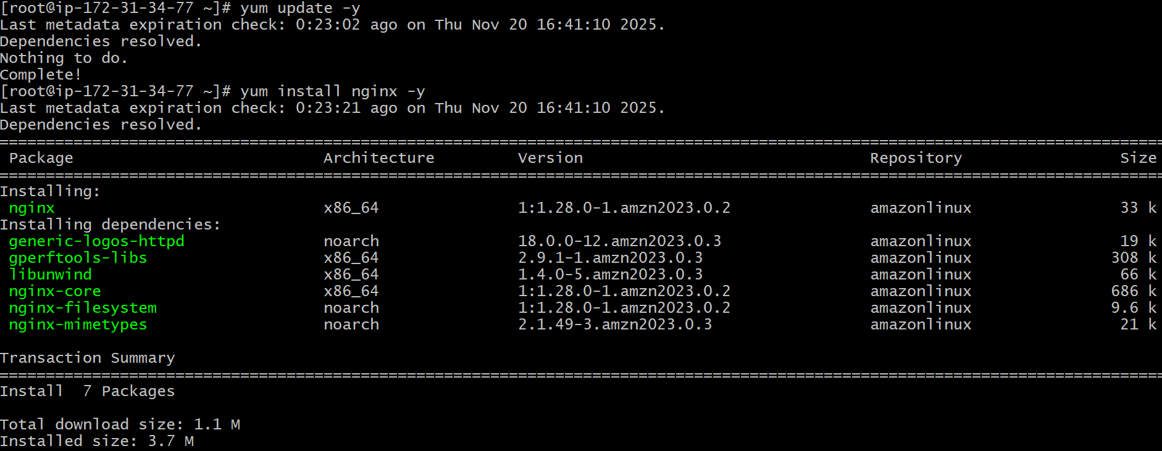
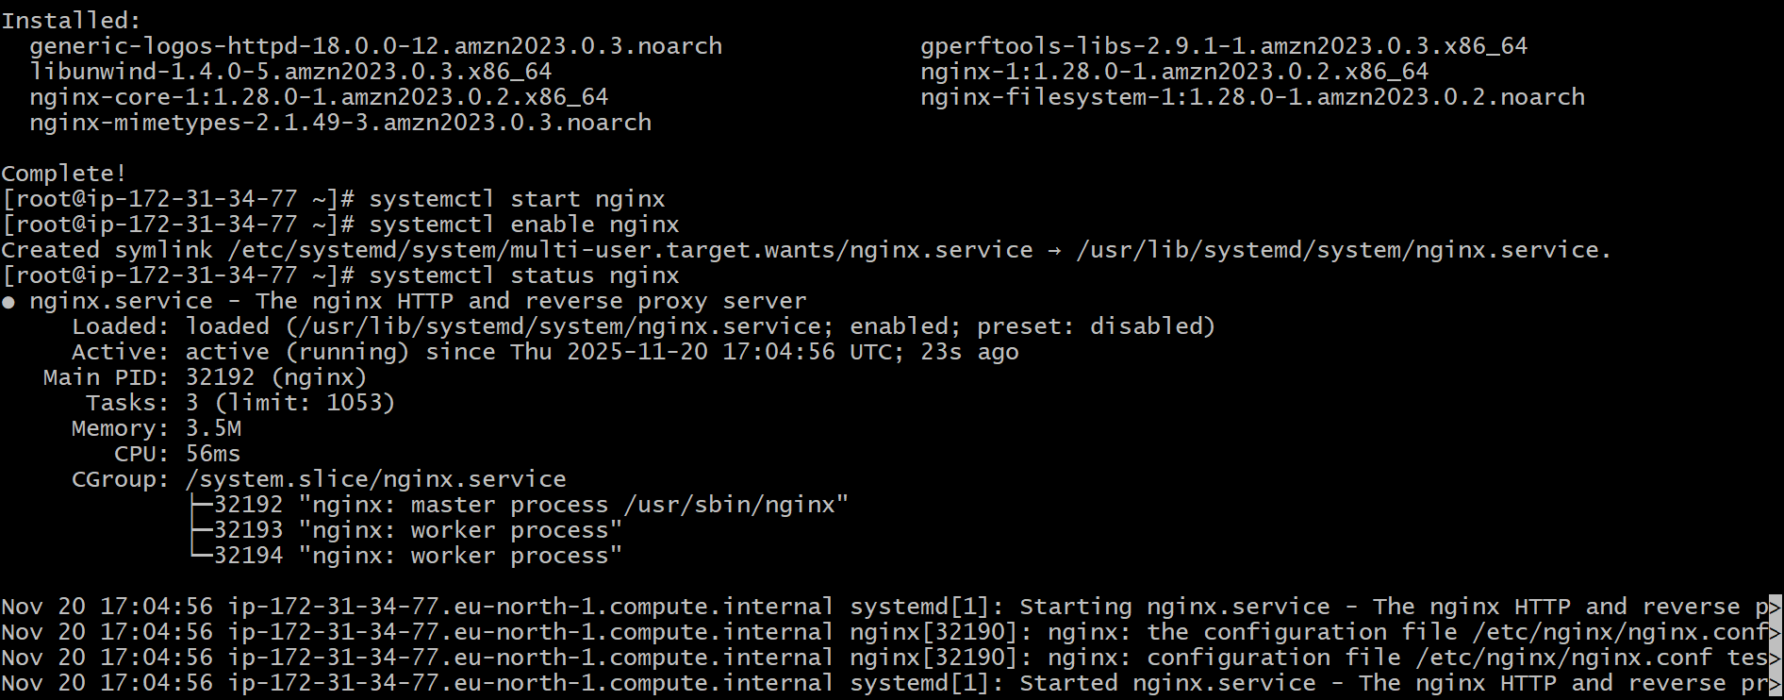
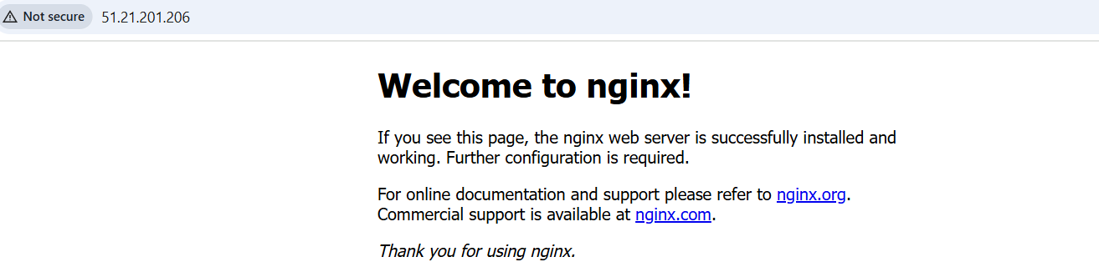

Install Apache.
Yum update -y
Yum install httpd -y
Sytemctl start httpd
Systemctl status httpd
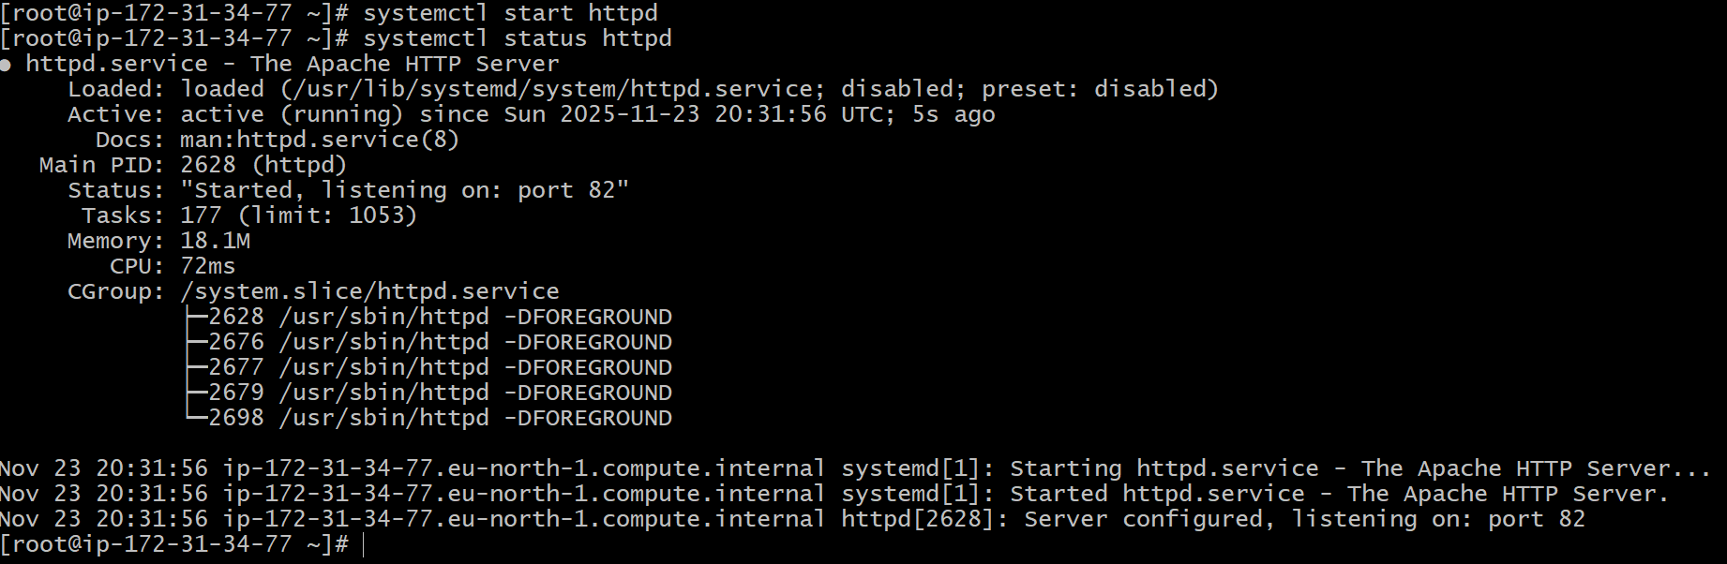
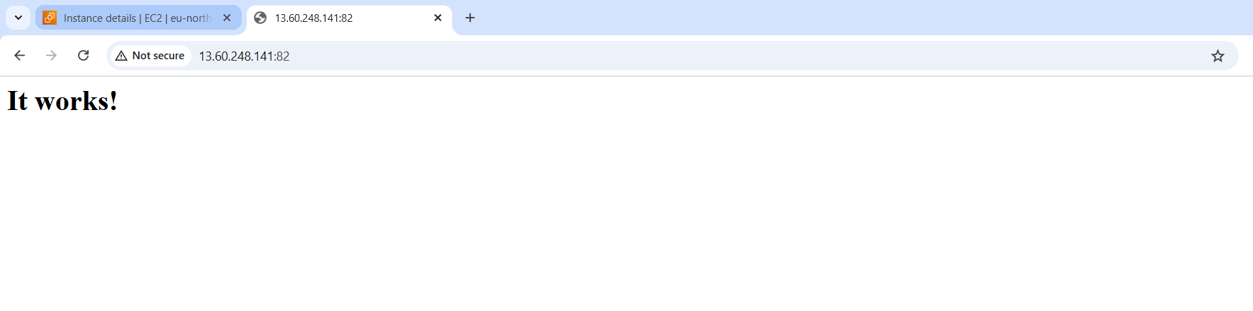

Install Apache Tomcat.
To install Apache tomcat we will copy the link from browser and paste the link along with wget command.
After that we need to extract the tar file.
Then if we do ls we will find bin and after entering bin we fill find startup.sh a script for tomcat to start . we can start using ./startup.sh.
And to change the port number we need to edit the sever.xml inside the conf directory.
After that we should go to gin folder then ./shutdown.sh if tomcat if running else ./startup.as
